|  |  |  |
| --- | --- | --- |
| **ITMD 510** | ***Object Oriented App Development*** | Lab 1 |

|  |  |  |  |
| --- | --- | --- | --- |
| **Student Name** | ***Rahul Mittal*** | **Section** | **01** |

# **Output:**

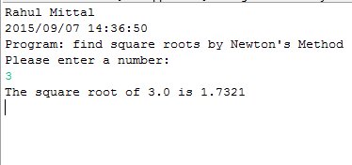

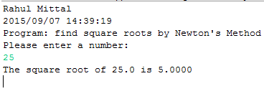

# **Code Snippet:**

/**

* Name: Rahul Mittal

* Lab Name: ITMD_510_01_LAB_01

* Current Date: 09/07/2015

*/

**import** java.util.Date;

**import** java.text.DateFormat;

**import** java.text.SimpleDateFormat;

**import** java.text.DecimalFormat;

**import** java.util.Scanner;

**public** **class** Newton {

/**

* Function to compute Square Root

* **@param** num for which square root need to be calculated

* **@return** the square root of the number

**/

**public** **static** **float** Compute(**float** num)

{

//variable to hold the approximate value of the square root.

**float** sqrRoot = 0;

//variable to hold the value of the Xn - 1

**float** prev = 0;

//Calculate X0 to start the calculation

prev = num / 2;

**for**( ; ;)

{

//apply Newton method for calculating the Xn.

sqrRoot = prev - ( (prev * prev - num) / (2 * prev) );

//check the absolute value of the remaining value and

//if it is less than 0.0001 for approximation, then return

//the value of square root else store the value in prev.

**float** result = Math.*abs*(prev - sqrRoot);

**if** (result < 0.0001)

**return** sqrRoot;

**else** prev = sqrRoot;

}

}

**public** **static** **void** main(String[] args)

{

// declare a Scanner class object

Scanner sc = **new** Scanner(System.***in***);

// declare a DecimalFormat class object

DecimalFormat fourDecimal = **new** DecimalFormat("0.0000");

**float** Number = 0;

DateFormat dateFormat = **new** SimpleDateFormat("yyyy/MM/dd HH:mm:ss");

Date date = **new** Date();

System.***out***.println("Rahul Mittal");

System.***out***.println(dateFormat.format(date)); //2015/09/07 14:19:25

System.***out***.println("Program: find square roots by Newton's Method");

System.***out***.println("Please enter a number: ");

Number = sc.nextFloat();

System.***out***.println("The square root of " + Number +

" is " + fourDecimal.format(*Compute*(Number)));

}

}